Year 11 Computer Science Task One
Rafe Milner

Problem Definition
Problem
- Mushroom Cafe owner Mario Mushroom needs to calculate wages for his employees based on the hours they've worked, payment modifiers based on holidays and weekends, and different pay rates based on the role of the individual. These operations are currently carried out manually in a process that is too time consuming.

Requirements for solution
- A text-based user interface (Mr Mushroom likes text-based interfaces as it makes him “feel like a hacker”)
- Ability to enter the hours worked over the week for each day, and to be able to specify if a day is a public holiday.
- A view that provides an output from wage calculations
- A view for hours worked by employees over the week
- A view showing the employee that has worked the most

Proposed Solution
- Filler

Time Plan
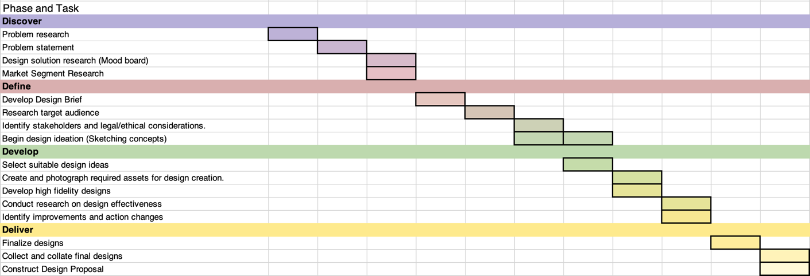
Gant Chart

Program design
Overview

Control structures
- Iteration Logic
  - What?
    - Filler text

  - Why?
    - Filer text

  - Example with explanation
    - Filer text

- Selection Logic
  - What?
    - Filler text

  - Why?
    - Filer text

  - Example with explanation
    - Filer text
Data Types
- String
  - Input validation
    - Filler text

  - Exception handling
    - Filer text

  - Example with explanation
    - Filer text

- Integer
  - Input validation
    - Filler text

  - Exception handling
    - Filer text

  - Example with explanation
    - Filer text

- Array
  - Input validation
    - Filler text

  - Exception handling
    - Filer text

  - Example with explanation
    - Filer text

Algorithms
Main

UserInput

Pay Calculations with modifier

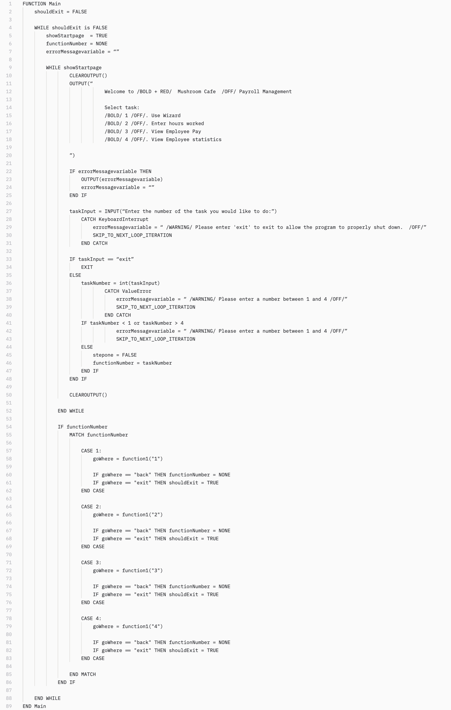
Main algorithm (Pseudo Code + Explanations)
Set global variable to determine whether main loop should continue to loop.

Define main_loop which allows the program to return to its start page at any point.

Structure Chart

Trace Table

Black Box Testing Suite

